Integral Calculus

The process of differentiation and integration are inverses of each other in the
sense of the following results :
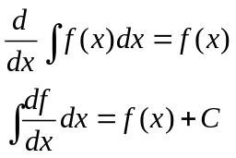
where C is an arbitrary constant.

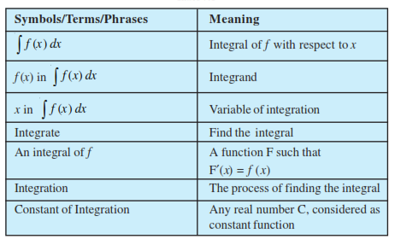

Two indefinite integrals with the same derivative lead to the same family of
curves and so they are equivalent.
The equivalence of the families 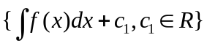 and 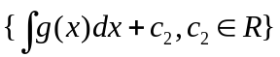
is customarily expressed by writing 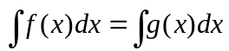 , without mentioning the parameter.

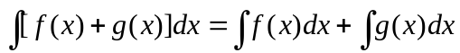
For any real number k, 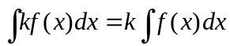

We see that if F is an anti derivative of f, then so is F + C, where C is any
constant. Thus, if we know one anti derivative F of a function f, we can write
down an infinite number of anti derivatives of f by adding any constant to F
expressed by F(x) + C, 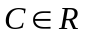. In applications, it is often necessary to satisfy an
additional condition which then determines a specific value of C giving unique
anti derivative of the given function.

Some basic Formulae

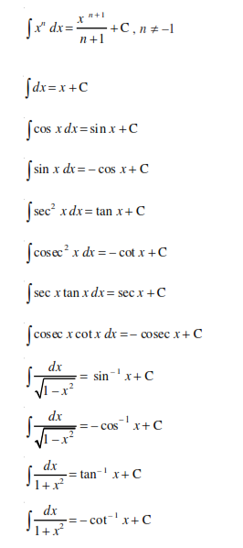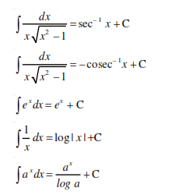

Results using Substitution Method

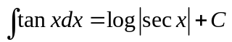
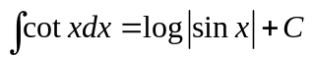
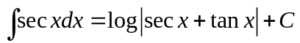
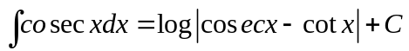

Some more standard integrals

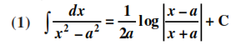
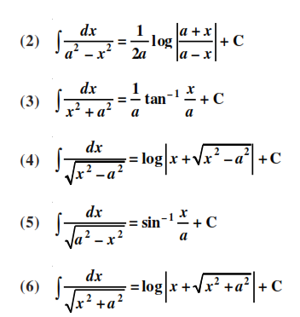

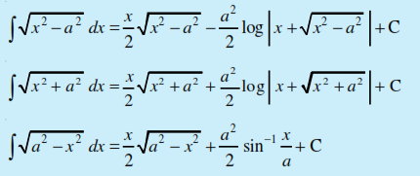

Comparison between differentiation and integration

1. Both are operations on functions.
2. Both satisfy the property of linearity, i.e.
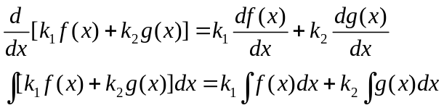 where k₁ and k₂ are constants.
3. All functions are not differentiable. Similarly, all functions are not
integrable.
4. The derivative of a function, when it exists, is a unique function. The
integral of a function is not so. However, they are unique upto an
additive constant, i.e., any two integrals of a function differ by a
constant.
5. When a polynomial function P is differentiated, the result is a
polynomial whose degree is 1 less than the degree of P. When a
polynomial function P is integrated, the result is a polynomial whose
degree is 1 more than that of P.
6. We can speak of the derivative at a point. We never speak of the
integral at a point, we speak of the integral of a function over an
interval on which the integral is defined.
7. The derivative of a function has a geometrical meaning, namely, the
slope of the tangent to the corresponding curve at a point. Similarly,
the indefinite integral of a function represents geometrically, a family
of curves placed parallel to each other having parallel tangents at the
points of intersection of the curves of the family with the lines
orthogonal (perpendicular) to the axis representing the variable of
integration.
8. The derivative is used for finding some physical quantities like the
velocity of a moving particle, when the distance traversed at any time t
is known. Similarly, the integral is used in calculating the distance
traversed when the velocity at time t is known.
9. Differentiation is a process involving limits, so is integration.
10. The process of differentiation and integration are inverses of each
other.

